Spring的JavaMailSender发送邮件

<http://blog.csdn.net/Guerlei/article/details/53189522>

JavaMailSender在**spring-context-support.jar**中。

## 利用maven添加依赖

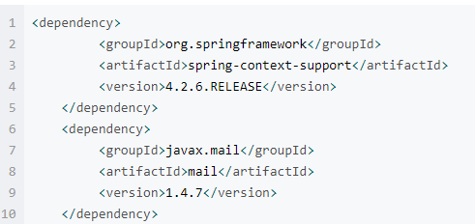

<dependency>

<groupId>org.springframework</groupId>

<artifactId>**spring-context-support**</artifactId>

<version>4.2.6.RELEASE</version>

</dependency>

<dependency>

<groupId>javax.mail</groupId>

<artifactId>mail</artifactId>

<version>1.4.7</version>

</dependency>

注意：mail.jar包对应的就是javax.mail.*;

## applicationContext.xml配置如下：

<?xml version="1.0" encoding="UTF-8"?>

<!DOCTYPE beans PUBLIC "-//SPRING//DTD BEAN//EN" "http://www.springframework.org/dtd/spring-beans.dtd">

<beans>

<bean id="configurer" class="org.springframework.beans.factory.config.PropertyPlaceholderConfigurer">

<property name="locations">

<list>

<value>/mail.properties</value>

</list>

</property>

</bean>

<bean class="org.springframework.beans.factory.annotation.AutowiredAnnotationBeanPostProcessor" />

<bean id="MailSenderDemo" class="com.mail.MailSenderDemo">

</bean>

</beans>

## mail.properties文件

主要是邮箱服务器、个人邮箱用户名和密码

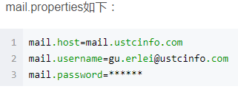

## spring-mail.xml如下：

<?xml version="1.0" encoding="UTF-8"?>

<!DOCTYPE beans PUBLIC "-//SPRING//DTD BEAN//EN" "http://www.springframework.org/dtd/spring-beans.dtd">

<beans>

<bean id="mailSender" class="org.springframework.mail.javamail.JavaMailSenderImpl">

<property name="host" value="${mail.host}"></property>

<property name="javaMailProperties">

<props>

<prop key="mail.smtp.auth">true</prop>

<prop key="mail.smtp.timeout">25000</prop>

</props>

</property>

<property name="username" value="${mail.username}"></property>

<property name="password" value="${mail.password}"></property>

</bean>

</beans>

## MailSenderDemo.java如下：

package com.mail;

import org.springframework.beans.factory.annotation.Autowired;

import org.springframework.mail.SimpleMailMessage;

import org.springframework.mail.javamail.JavaMailSender;

public class MailSenderDemo {

@Autowired

private JavaMailSender mailSender;

public void send(SimpleMailMessage mail){

mailSender.send(mail);

}

}

## 测试类SendTest.java如下:

package com.mail;

import org.springframework.context.ApplicationContext;

import org.springframework.context.support.ClassPathXmlApplicationContext;

import org.springframework.mail.SimpleMailMessage;

public class SendTest {

public static void main(String[] args) {

ApplicationContext ac = new ClassPathXmlApplicationContext("spring-mail.xml",

"applicationContext.xml");

MailSenderDemo sender = (MailSenderDemo)ac.getBean("MailSenderDemo");

SimpleMailMessage mail = new SimpleMailMessage();

mail.setTo("gu.erlei@ustcinfo.com");//收件人邮箱地址

mail.setFrom("gu.erlei@ustcinfo.com");//收件人

mail.setSubject("spring自带javamail发送的邮件");//主题

mail.setText("hello this mail is from spring javaMail ");//正文

**sender.send(mail);**

}

}

注意：最后要保证pom.xml中的配置jar的版本的准确，否侧可能会报类似找不到方法的错。。。比如**spring-expression3.2.4**会报错，换成4.2.6就可以了。